VIETNAM NATIONAL UNIVERSITY – HO CHI MINH CITY
THE INTERNATIONAL UNIVERSITY

SCHOOL OF COMPUTER SCIENCE AND ENGINEERING


FINAL REPORT
TOPIC: PAYROLL MANAGEMENT SOLUTION
By Group 9 - Member list
1 | Nguyễn Hữu Minh Nguyễn (Leader) | ITITIU21089
2 | Tôn Quang Tấn | ITITIU22205
3 | Hoàng Thị Ngọc Mai | SESEIU23017
4 | Nguyễn Trầm Gia Hưng | ITITIU23007
5 | Lê Tấn Thịnh | ITCSIU22239
6 | Nguyễn Vũ Anh Duy | ITCSIU21178

Course name: Principles of Database Management
Instructor: Assoc. Prof. Nguyen Thi Thuy Loan

Table of Contents
Chapter I. Introduction 1
1. System Overview 1
2. Objective 1
3. The techniques & tools used 1
Chapter II. Task timeline & division 2
1. Contribution 2
2. Project timeline & task division 2
Chapter IV. Methodology 4
1. Requirements analysis 4
2. Research method analysis 4
2.1. Reviewed Materials 4
2.2. Research Approach 4
3. System analysis 5
3.1. Database Design 5
3.2. Database and Tables Creation 6
3.3. Database Data Insertion 9
3.4. Database Queries 11
3.5. Java Application Setup 14
3.6. Application demo – Screenshot 19
Chapter V. Conclusion 24
1. Achieved goals 24
2. Future work 24
3. Concluding thoughts 24
List of references 25

List of Figures
Figure 1: Project Entity Relationship Diagram created by using draw.io 5
Figure 2: Relational Schema created by using draw.io 5
Figure 3: Java application directory 15
Figure 4: XAMPP 16
Figure 5: XAMPP local host, MySQL database 16
Figure 6: JDBC Download page 17
Figure 7: Import JDBC to Java Project 17
Figure 8: DbConnection class 18
Figure 9: GUI builder 18
Figure 10: Login page when start up application 19
Figure 11: Pop up notification when checking attendance 19
Figure 12: HR Homepage 20
Figure 13: Change Password 20
Figure 14: Add new Employee 21
Figure 15: Manage Employee Information 21
Figure 16: Manage Payroll 22
Figure 17: Default Homepage 23
Figure 18: Checking payroll record 23

List of tables
Table 1: Individual responsibility and contribution 2
Table 2 Detail timeline and task division 2
Table 3: Normal form achievement 6

Abstract
For all businesses, payroll management is an important monthly process. Therefore, our team decided to develop a database management application specifically for payroll management for the Principles of Database Management project. Key features include employee management, automatic monthly salary calculation, attendance tracking, and more. The application is also built with user-friendly interfaces.

Through this project, all of the team members have learned how to apply practical DBMS knowledge to develop the application. At the same time, improving SQL skills, Java, UI design, and teamwork.

Introduction

System Overview
Managing payroll is a fundamental aspect of human resource management within any organization. The complexity of payroll management increases with the size of the workforce and the diversity of employee compensation structures. This proposal outlines the development of a comprehensive Payroll Management Solution (PMS) that leverages a database system to streamline the payroll process, ensuring accuracy, compliance, and efficiency.

Objective
- To learn and master SQL/ DBMS
- Successfully design an usable application with GUI (front end) and database (backend)
- Develop all intended features and improve
- Database Connectivity (JDBC)

The techniques & tools used
- Draw.io and ERD plus for designing ERD, and Relational databases.
- MySQL for main DBMS. XAMPP, JDBC to create a local host to connect between the application and database.
- Java with Netbeans IDE to design GUI.
- Figma to briefly design the UI for implementation.

Task timeline & division

Contribution
Table 2.1: Individual responsibility and contribution
Nguyễn Hữu Minh Nguyễn | ITITIU21089 | 20%
Tôn Quang Tấn | ITITIU22205 | 20%
Hoàng Thị Ngọc Mai | SESEIU23017 | 20%
Nguyễn Trầm Gia Hưng | ITITIU23007 | 20%
Lê Tấn Thịnh | ITCSIU22239 | 20%
Nguyễn Vũ Anh Duy | ITCSIU21178 | 20%

Project timeline & task division
Table 2.2 Detail timeline and task division
Time | No. | Tasks | Member
Week 1 - 4  Proposal | 1 | Choosing topic | All members
 | 2 | Write an introduction and general information  about the topic. | Nguyễn/ Tấn/ Hưng
 | 3 | Write a timeline for the proposal and edit the  Word file. | Nguyễn/ Mai
 | 4 | Check for mistakes to complete the proposal. | All members
Week 5-7  Research, learn SQL, and find data for the project. | 7 | Do research, find data sources. | All members
 | 8 | Design database ERD model and Relational database. | Thịnh/ Duy
 | 9 | Analyze information,  filter information. | Nguyễn/Tấn
 | 10 | Prepare for a midterm report. | All members
 | 11 | Meetings for discussion. | All members
Week 8-10  Apply SQL and Java to build a database application. | 12 | Create a database using MySQL, and apply it with the previous data. | All members
 | 13 | Design GUI through Java
 | 14 | Building app / debugging/ checking for errors.
 | 15 | Meetings for discussion.
Week 11-12  Complete the project and test. | 16 | Finishing final project, checking for errors/ bugs.  Writing Final report | All members
 | 17 | Attend pair meetings for discussion
Week 13+  Final recap | 18 | Prepare for presentation, rehearsal presentation. | All members
 | 19 | Meetings for discussion.
 | 20 | Implement future improvement for the project

Methodology

Requirements analysis
The proposed project aims to develop a database system that is able to manage employee accounts, employee information, calculate salaries, generate payslips, check attendance, …

Research method analysis

Reviewed Materials
- Principles of Database Management course lecture slides
- Fundamentals of Database Systems (Book by Ramez Elmasri and Shamkant Navathe)
- Java GUI Applications Learning Trail (https://netbeans.apache.org/tutorial/main/kb/)
- MySQL 8.0 Reference Manual ( https://docs.oracle.com/cd/E17952_01/mysql-8.0-en /index.html )

Research Approach
- Determine who will use the system (e.g., HR, employee).
- Specify the system's capabilities, such as calculating payroll, generating reports, and handling taxes.
- Select a suitable DBMS (MySQL, XAMPP) based on project requirements and functionality.
- Create a user-friendly application by using Java. That can connect with a database, for data entry, retrieval, and calculation.

System analysis

Database Design
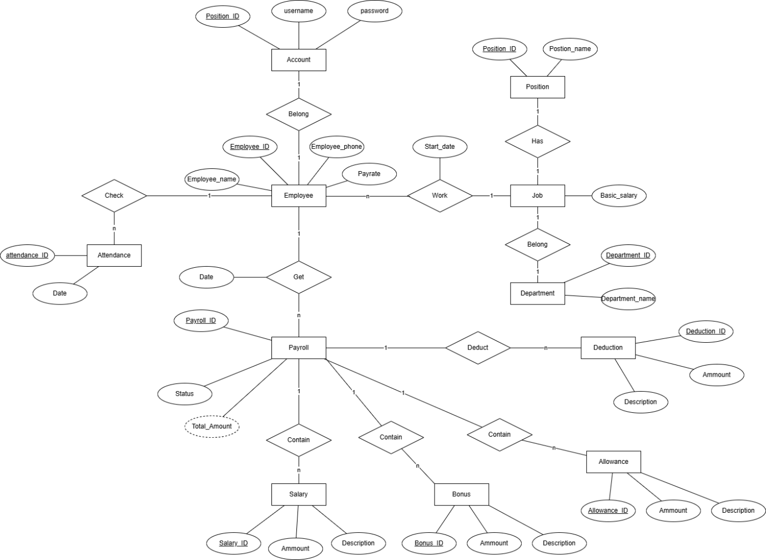
Figure 1: Project Entity Relationship Diagram created by using draw.io

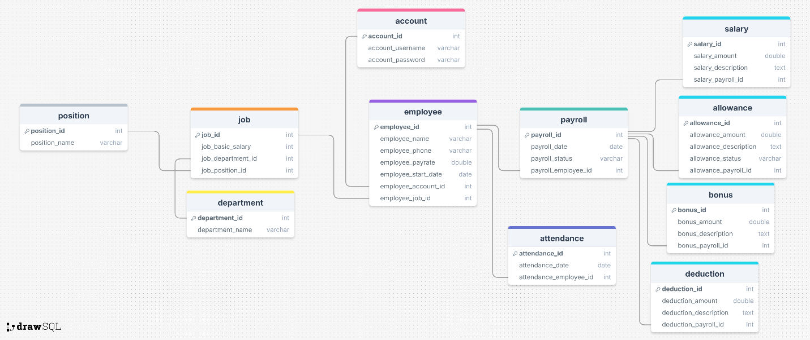
Figure 2: Relational Schema created by using draw.io

Based on 2 figures above, our database achieved the Boyce-Codd NF which is illustrated below:

Table 3: Normal form achievement
Normal Form | Description
1 N.F | Each table cell should contain a single value.  Ever table has primary key.
2 N.F | Each non-key attribute in the table must be dependent on the entire primary key.
3 N.F | Every non-key attribute is nontransitively dependent on every key
BC N.F. | Each attribute in the table must depend on the key, the whole key, and nothing but the key

Database and Tables Creation
This part illustrated the database, table creation process, following the E.R.D and Relational schema, which designed in Section 3.1.Database Design (Firgure 1, 2).
The following code is created using MySQL database.

Database Creation
/* CREATE DATABASE*/
CREATE DATABASE payroll;
USE payroll;

Table Creation
Account Table:
CREATE TABLE `account`(
`account_id` INT UNSIGNED NOT NULL AUTO_INCREMENT PRIMARY KEY,
`account_username` VARCHAR(20) NOT NULL UNIQUE,
`account_password` VARCHAR(20) NOT NULL
);

Position Table:
CREATE TABLE `position`(
`position_id` INT UNSIGNED NOT NULL AUTO_INCREMENT PRIMARY KEY,
`position_name` VARCHAR(20) NOT NULL
);

Department Table:
CREATE TABLE `department`(
`department_id` INT UNSIGNED NOT NULL AUTO_INCREMENT PRIMARY KEY,
`department_name` VARCHAR(20) NOT NULL
);

Job Table:
CREATE TABLE `job`(
`job_id` INT UNSIGNED NOT NULL AUTO_INCREMENT PRIMARY KEY,
`job_basic_salary` INT NOT NULL,
`job_department_id` INT UNSIGNED NOT NULL,
`job_position_id` INT UNSIGNED NOT NULL
);

Employee Table:
CREATE TABLE `employee`(
`employee_id` INT UNSIGNED NOT NULL AUTO_INCREMENT PRIMARY KEY,
`employee_name` VARCHAR(20) NOT NULL,
`employee_phone` VARCHAR(20) NOT NULL,
`employee_payrate` DOUBLE NOT NULL,
`employee_start_date` DATE NOT NULL,
`employee_account_id` INT UNSIGNED NOT NULL,
`employee_job_id` INT UNSIGNED NOT NULL
);

Attendance Table:
CREATE TABLE `attendance`(
`attendance_id` INT UNSIGNED NOT NULL AUTO_INCREMENT PRIMARY KEY,
`attendance_date` DATE NOT NULL,
`attendance_employee_id` INT UNSIGNED NOT NULL
);

Payroll Table:
CREATE TABLE `payroll`(
`payroll_id` INT UNSIGNED NOT NULL AUTO_INCREMENT PRIMARY KEY,
`payroll_date` DATE NOT NULL,
`payroll_status` VARCHAR(20) NOT NULL,
`payroll_employee_id` INT UNSIGNED NOT NULL
);

Salary Table:
CREATE TABLE `salary`(
`salary_id` INT UNSIGNED NOT NULL AUTO_INCREMENT PRIMARY KEY,
`salary_amount` DOUBLE NOT NULL,
`salary_description` TEXT NOT NULL,
`salary_payroll_id` INT UNSIGNED NOT NULL
);

Deduction Table:
CREATE TABLE `deduction`(
`deduction_id` INT UNSIGNED NOT NULL AUTO_INCREMENT PRIMARY KEY,
`deduction_amount` DOUBLE NOT NULL,
`deduction_description` TEXT NOT NULL,
`deduction_payroll_id` INT UNSIGNED NOT NULL
);

Allowance Table:
CREATE TABLE `allowance`(
`allowance_id` INT UNSIGNED NOT NULL AUTO_INCREMENT PRIMARY KEY,
`allowance_amount` DOUBLE NOT NULL,
`allowance_description` TEXT NOT NULL,
`allowance_status` VARCHAR(20) NOT NULL,
`allowance_payroll_id` INT UNSIGNED NOT NULL
);

Bonus Table:
CREATE TABLE `bonus`(
`bonus_id` INT UNSIGNED NOT NULL AUTO_INCREMENT PRIMARY KEY,
`bonus_amount` DOUBLE NOT NULL,
`bonus_description` TEXT NOT NULL,
`bonus_payroll_id` INT UNSIGNED NOT NULL
);

Foreign Key
/* FOREIGN KEY */
ALTER TABLE
`job` ADD CONSTRAINT `job_job_position_id_foreign` FOREIGN KEY(`job_position_id`) REFERENCES `position`(`position_id`);
ALTER TABLE
`bonus` ADD CONSTRAINT `bonus_bonus_payroll_id_foreign` FOREIGN KEY(`bonus_payroll_id`) REFERENCES `payroll`(`payroll_id`);
ALTER TABLE
`employee` ADD CONSTRAINT `employee_employee_job_id_foreign` FOREIGN KEY(`employee_job_id`) REFERENCES `job`(`job_id`);
ALTER TABLE
`deduction` ADD CONSTRAINT `deduction_deduction_payroll_id_foreign` FOREIGN KEY(`deduction_payroll_id`) REFERENCES `payroll`(`payroll_id`);
ALTER TABLE
`payroll` ADD CONSTRAINT `payroll_payroll_employee_id_foreign` FOREIGN KEY(`payroll_employee_id`) REFERENCES `employee`(`employee_id`);
ALTER TABLE
`employee` ADD CONSTRAINT `employee_employee_account_id_foreign` FOREIGN KEY(`employee_account_id`) REFERENCES `account`(`account_id`);
ALTER TABLE
`job` ADD CONSTRAINT `job_job_department_id_foreign` FOREIGN KEY(`job_department_id`) REFERENCES `department`(`department_id`);
ALTER TABLE
`allowance` ADD CONSTRAINT `allowance_allowance_payroll_id_foreign` FOREIGN KEY(`allowance_payroll_id`) REFERENCES `payroll`(`payroll_id`);
ALTER TABLE
`attendance` ADD CONSTRAINT `attendance_attendance_employee_id_foreign` FOREIGN KEY(`attendance_employee_id`) REFERENCES `employee`(`employee_id`);
ALTER TABLE
`salary` ADD CONSTRAINT `salary_salary_payroll_id_foreign` FOREIGN KEY(`salary_payroll_id`) REFERENCES `payroll`(`payroll_id`);

Database Data Insertion

Source of data insertion
For testing purposes, our team members typically self-generate all of the data. In order to ascertain which data is required, we also do online searches during the design phase to see how businesses actually handle their payroll.
The data in payroll, and salary table also can be generated in application through calculations and sql query.
Later on, more data can be input directly through application UI. Before inputting into the database, the data will get validated.

Data insertion
Only the first five rows of each table are displayed in this report as a preview. The complete dataset of the database can be found in the attached file.
The following SQL queries must be executed in the following order. Otherwise, the queries cannot be executed due to foreign key constraints. Primary keys of each table are auto-numbering if not specified.

Department Table:
INSERT INTO Department
VALUES ('1', 'Human resources'),
('2', 'Sales'),
('3', 'IT'),
('4', 'Customer service'),
('5', 'Marketing')
;

Position Table:
INSERT INTO Position
VALUES ('1', 'Department head'),
('2', 'Team leader'),
('3', 'Senior'),
('4', 'Junior'),
('5', 'Intern')
;

Job Table:
INSERT INTO Job
VALUES ('1', '1000', '1','1'),
('2', '600', '1','2'),
('3', '400', '1','3'),
('4', '300', '1','4'),
('5', '100', '1','5'),
…
('25', '100', '5','5')
;

Account Table:
INSERT INTO Account
VALUES ('1','headhr','password'),
('2','hr1','password'),
('3','hr2','password'),
('4','hr3','password'),
('5','hr4','password'),
…
('10','sale4','password')
;

Employee Table:
INSERT INTO Employee
VALUES ('1', 'Erik', '0123456789', '1', '2024-11-27', '1', '1'),
('2', 'Erika', '1123456789', '1' ,'2024-11-27', '2', '2'),
('3', 'Eureka', '2123456789', '1' ,'2024-11-27', '3', '3'),
('4', 'Yaguchi', '3123456789', '1' ,'2024-11-27', '4', '4'),
…
('10', 'Clark Kent', '9923456789', '1' ,'2024-11-27', '10', '10')
;

Attendance Table:
INSERT INTO Attendance (attendance_date,attendance_employee_id)
VALUES ('2024-12-1', '1'),
('2024-12-2', '1'),
('2024-12-3', '1'),
('2024-12-4', '1'),
…
('2024-12-5', '10')
;

Payroll Table:
INSERT INTO payroll (payroll_date, payroll_status, payroll_employee_id)
VALUES
('2024-12-1', 'pending', '1'),
('2024-12-1', 'pending', '2'),
('2024-12-1', 'pending', '3'),
('2024-12-1', 'pending', '4'),
…
('2024-12-1', 'pending', '10')
;

Salary Table:
INSERT INTO `salary` (`salary_id`, `salary_amount`, `salary_description`, `salary_payroll_id`)
VALUES
(1, 6000, 'Salary of 12-2024', 1),
(2, 3000, 'Salary of 12-2024', 2),
(3, 2000, 'Salary of 12-2024', 3),
(4, 1500, 'Salary of 12-2024', 4),
…
(10, 1000, 'Salary of 12-2024', 10)
;

Database Queries
Our application employs a hybrid approach, utilizing Java for complex logical operations and SQL for efficient data management and retrieval. We created two Java methods to execute SQL queries in the database: sqlQuery(String sql) and sqlUpdate(String sql).
- sqlQuery: Returns a dataset and is used for 'SELECT' statements.
- sqlUpdate: Executes other SQL operations, such as 'INSERT', 'UPDATE', and 'DELETE'."
To execute SQL queries in a Java application, we first declare these three variables:
Java
SQLRun objSQLRun = new SQLRun();
String sql;
ResultSet rs;

SQLRun: This is a class containing the sqlQuery and sqlUpdate methods mentioned earlier.
sql: A string variable to hold the SQL query.
rs: A ResultSet object to store the results of the SQL query."

Account login, and register
User login authentication:

- Getting input:
String username = txtusername.getText();
String password = new String(txtpassword.getPassword());

-Check if there is any username/ password same with account table in database:
sql = ("SELECT * FROM `account` where account_username = '"+username+"' and account_password = '"+password+"'");
rs = objSQLRun.sqlQuery(sql);

-If the information is correct, the user will be directed to a different homepage corresponding to their department. Each homepage will offer specific functionalities tailored to the department's needs
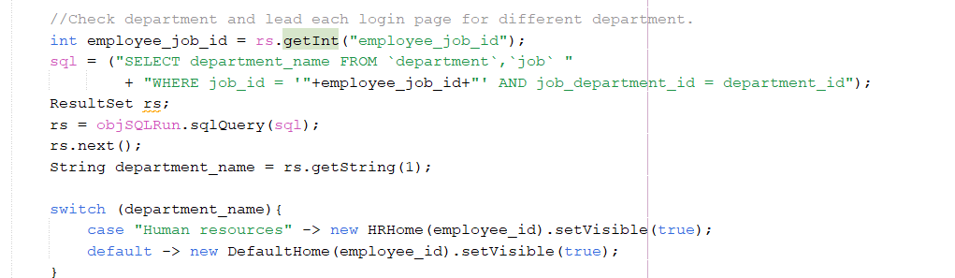

-On the homepage, we will display a personalized welcome message for the user. This message will retrieve the user's name from the database:
String sql = ("SELECT employee_name FROM `employee` where employee_id = '"+employeeID+"'");

-Changing account password:
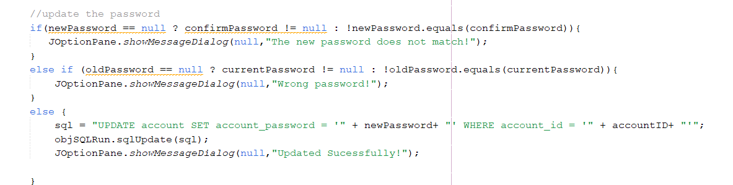

Checking Attendance
To check attendance, we first obtain the current date using Java's Calendar utility. Then, we verify if the user has an attendance record for that specific day. If no record exists, we insert a new record into the attendance table with the current date.

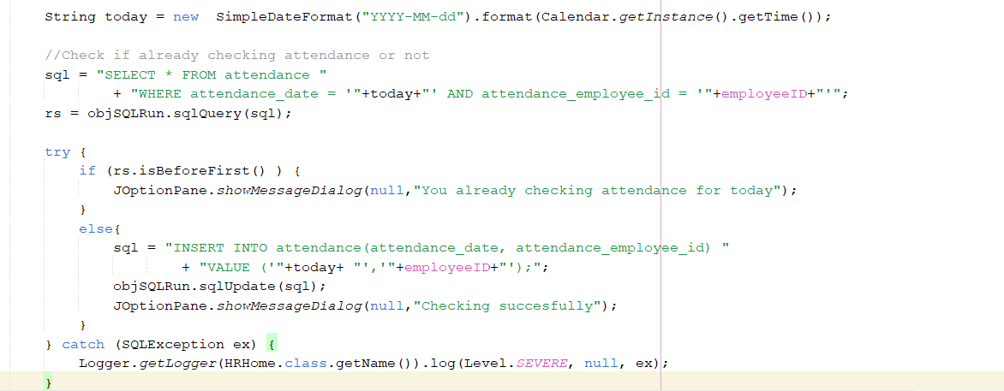

Calculating salary through attendance records
Basic formula for salary will be:
Salary = day * basic salary * payrate

First, we retrieve the number of days the employee worked in the current month based on the attendance records.
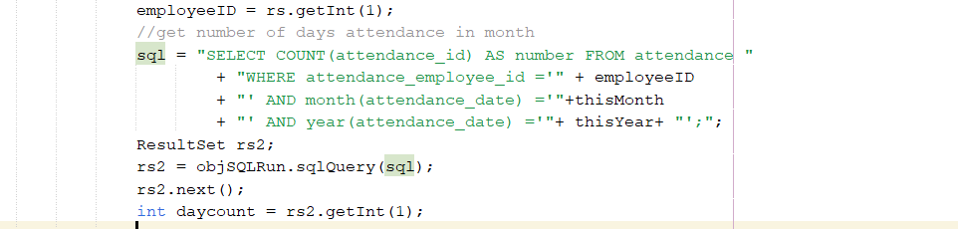

If the employee attend at least 1 day in the current month. The calculation process will begin.
Getting the payrate, and basic salary from the employee information:
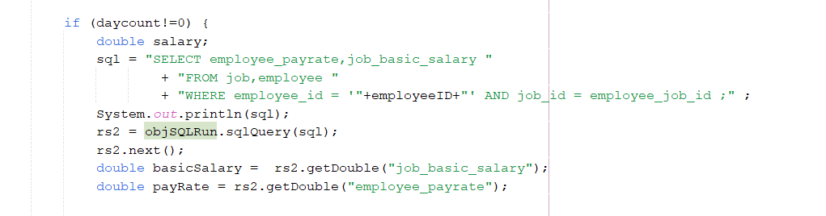
Calculating and insert to the database:
salary = daycount * basicSalary * payRate;
sql = "INSERT INTO salary(salary_amount,salary_description,salary_payroll_id) "
+ "VALUE ('"+salary+"','"+description+"','"+payrollID +"');";
objSQLRun.sqlUpdate(sql);

Java Application Setup

Overview
Our application is developed with JDK 21, a Long-Term Support (LTS) version of Java, known for its stability and cross-platform compatibility (Windows and macOS). We also selected NetBeans IDE as the main IDE, for its robust JFrame GUI Form builder, which significantly help us design the UI. For our database, we used local MySQL database set up through XAMPP, enabling connection between our Java application and the database.

Java
Netbeans IDE help us to manage all file for this project. The total file we created for this project will be shown as:
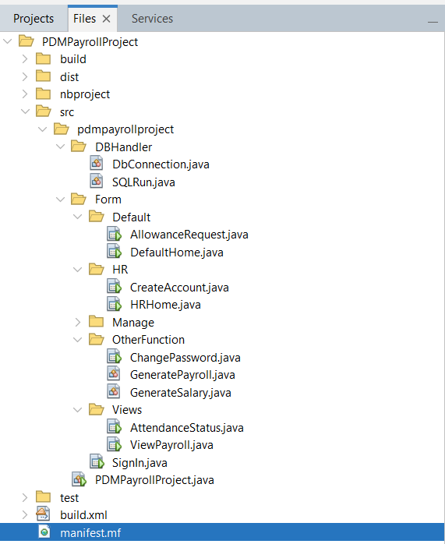
Figure 3: Java application directory

Database hosting tool (XAMPP)

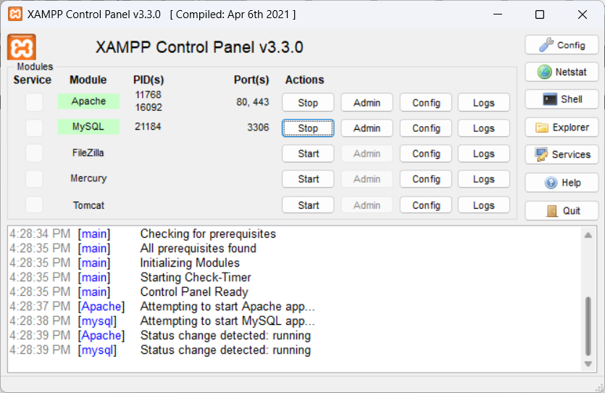
Figure 4: XAMPP
For XAMPP, the default connection information for the MySQL database are set at: port: 3306, username: root, password: (empty)

After start Apache and MySQL in XAMPP, we can access database in browser through : http://localhost/phpmyadmin
To excute SQL queries, change to SQL tab, input the query then hit run
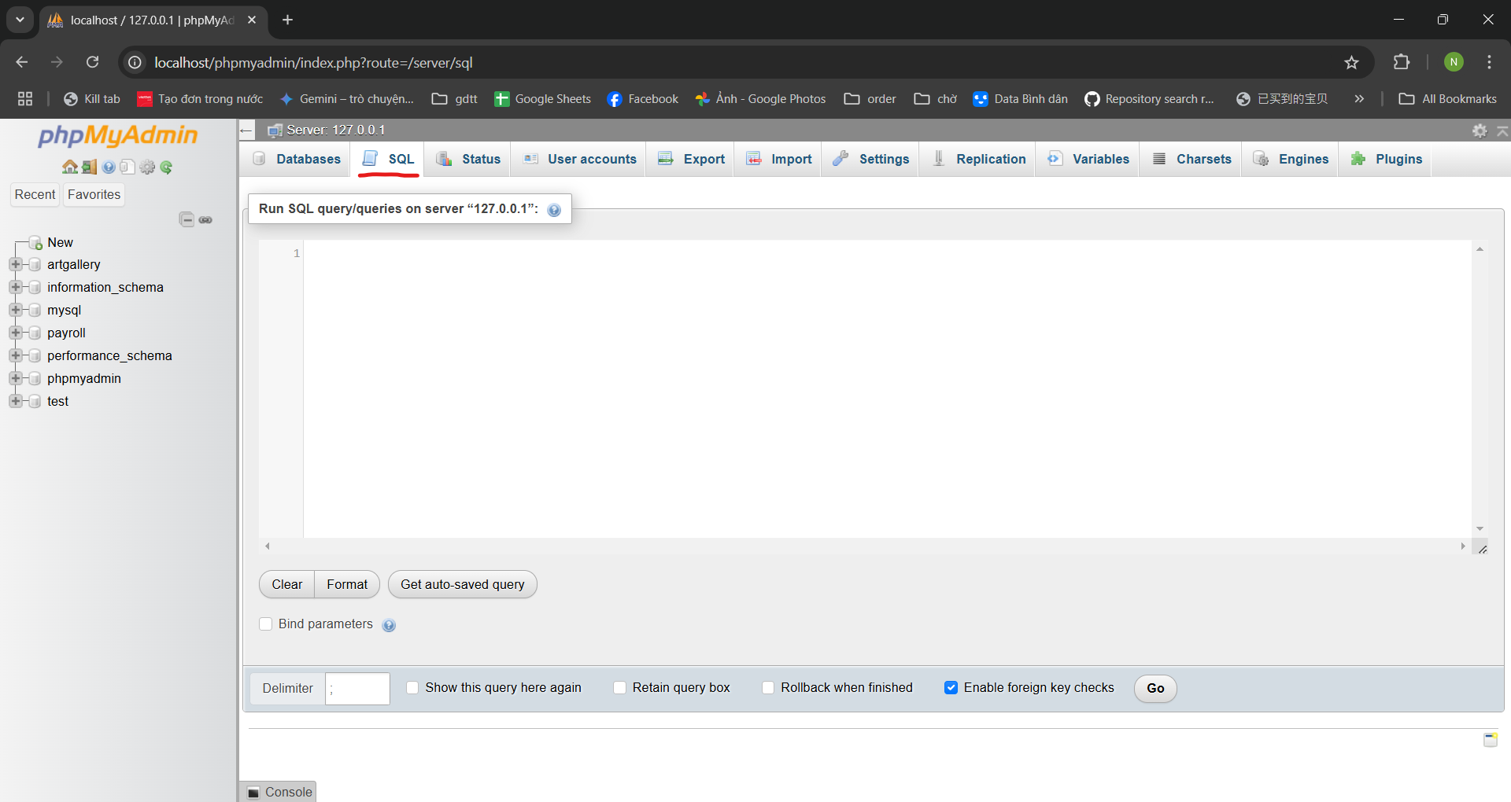
Figure 5: XAMPP local host, MySQL database

Database connection
To connect the Java application with the above MySQL database, a JDBC library is needed. Files of the library can be downloaded online on:
https://dev.mysql.com/downloads/connector/j/5.1.html
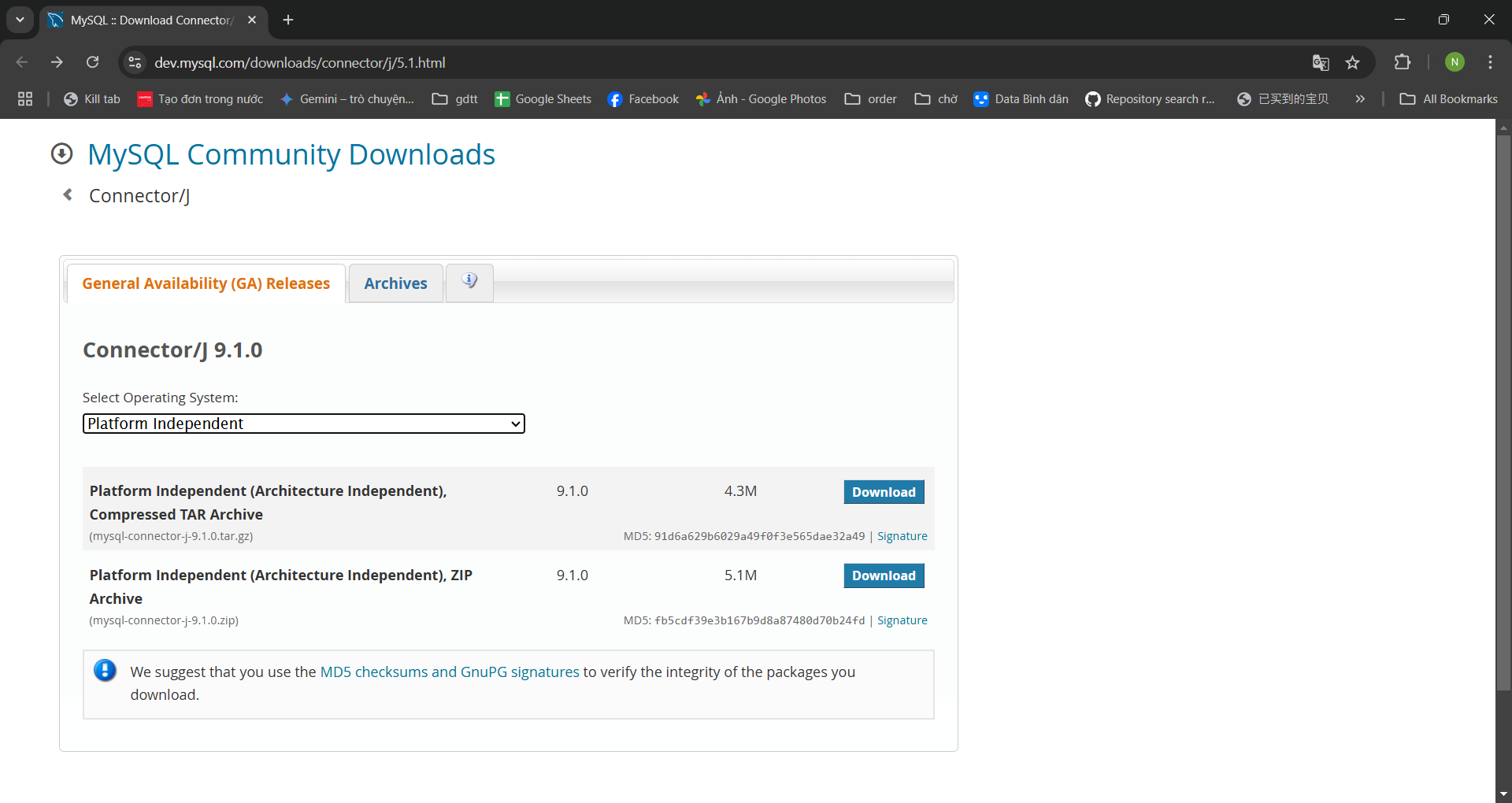
Figure 6: JDBC Download page

After downloaded, the library can be imported to the file project.
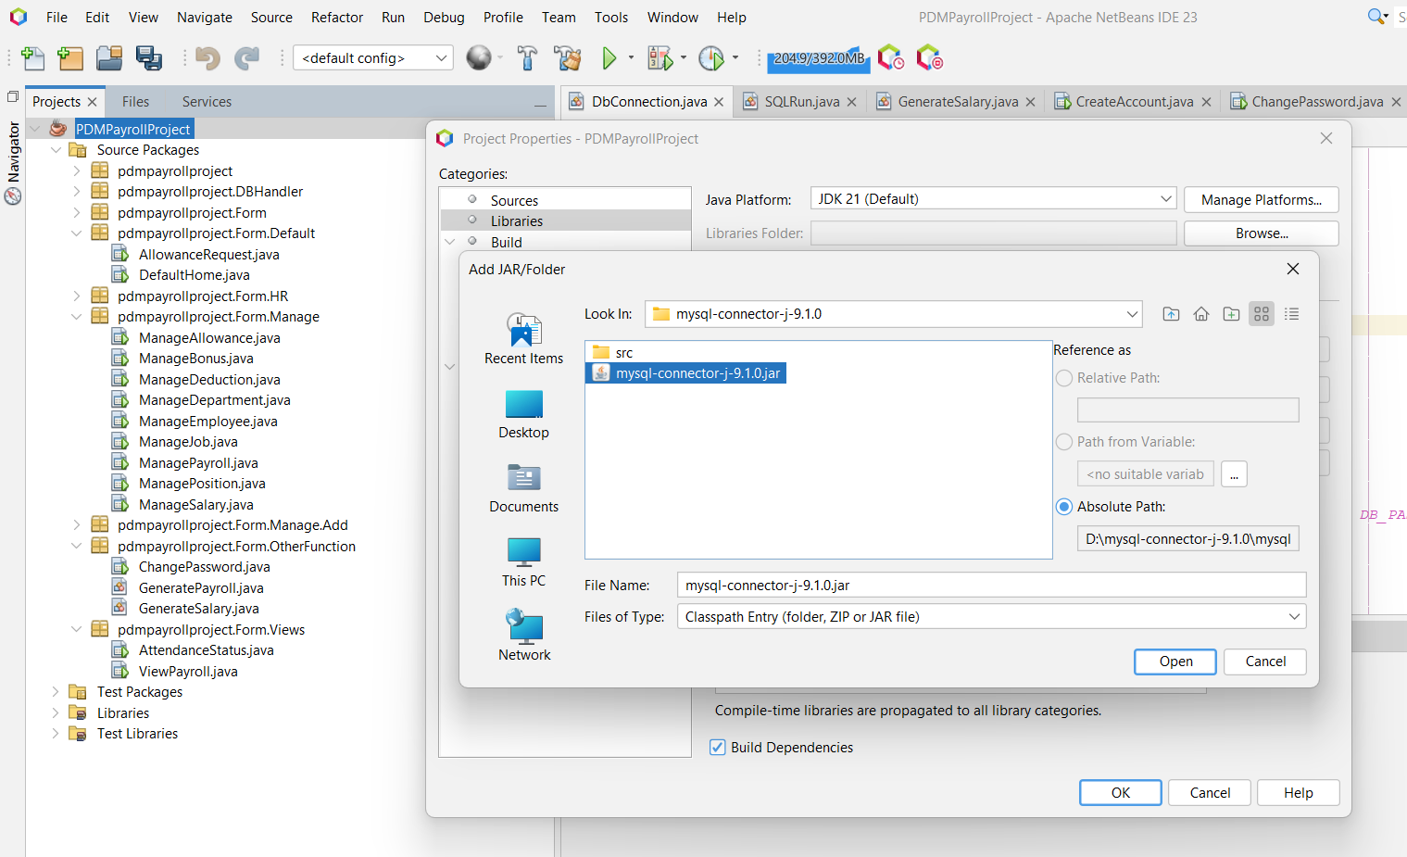
Figure 7: Import JDBC to Java Project

After add the needed file, we create DbConnection class. This DbConnection class provides a static method getConnection() to establish a database connection.
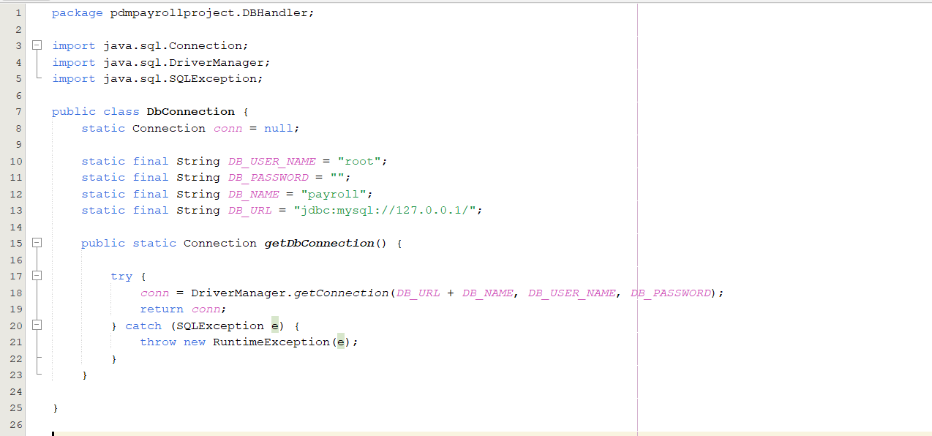
Figure 8: DbConnection class

GUI Design
NetBeans IDE provides a powerful visual form editor for creating Java Swing GUIs, including JFrame forms. Which have drag-and-drop interface, help the process of designing user interfaces, saving time and effort.
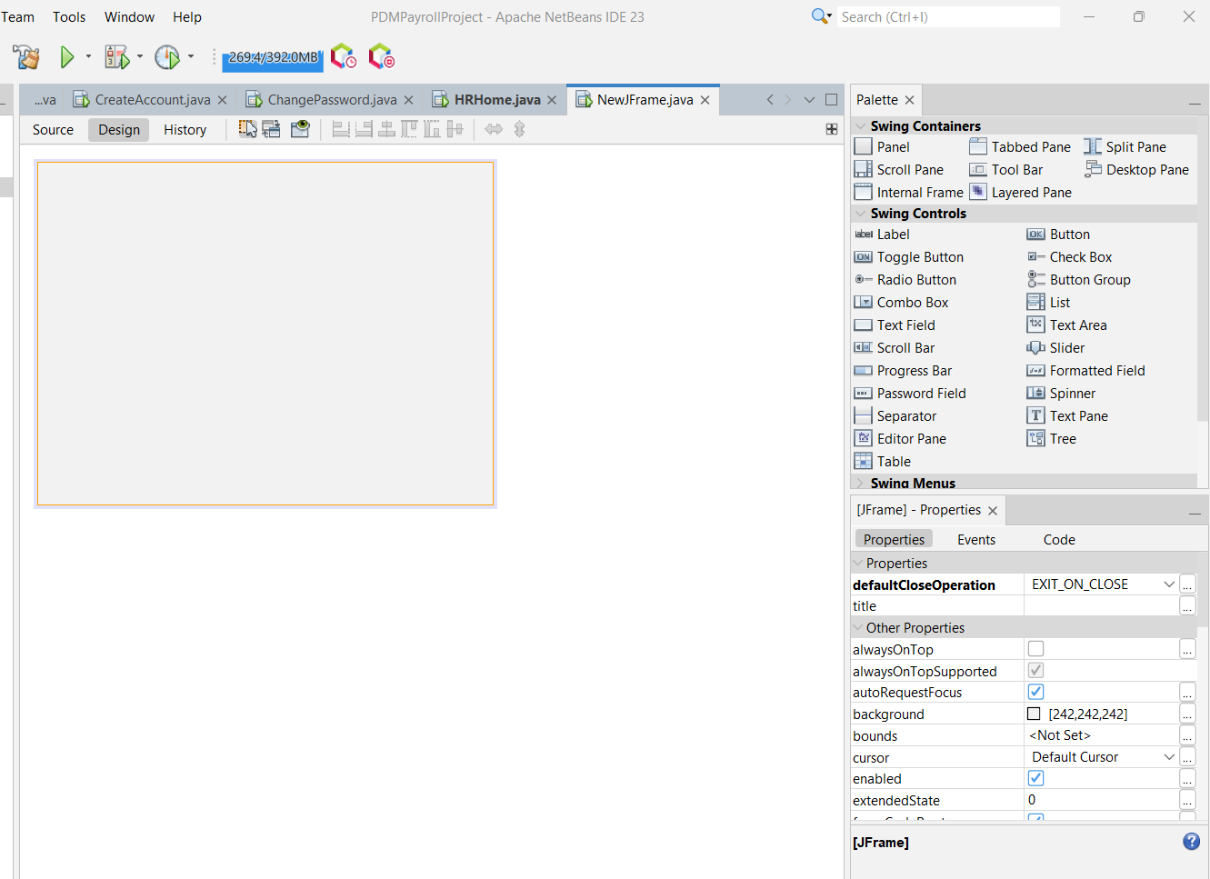

Figure 9: GUI builder

Application demo – Screenshot
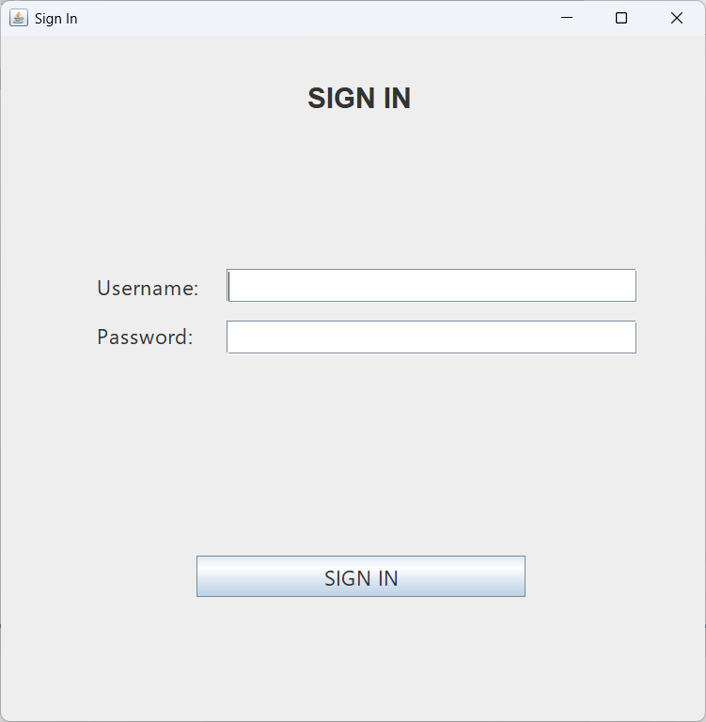
Figure 10: Login page when start up application
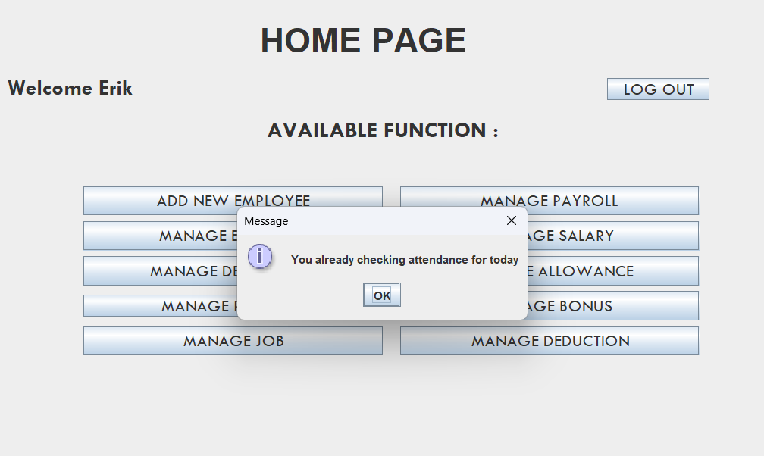
Figure 11: Pop up notification when checking attendance
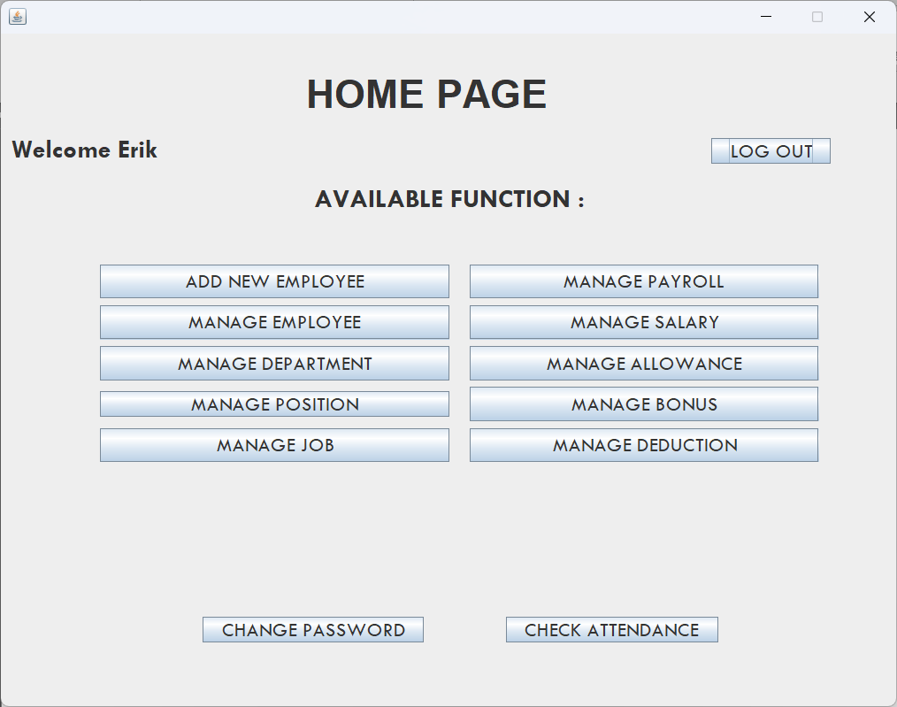
Figure 12: HR Homepage
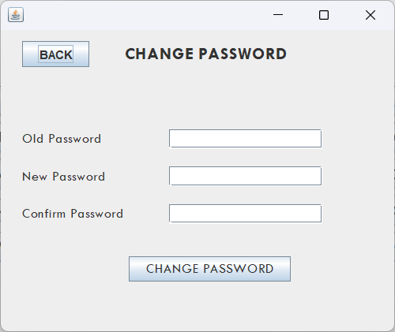
Figure 13: Change Password
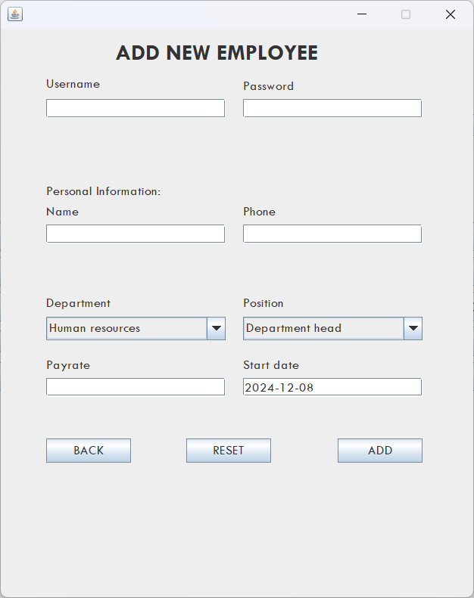
Figure 14: Add new Employee

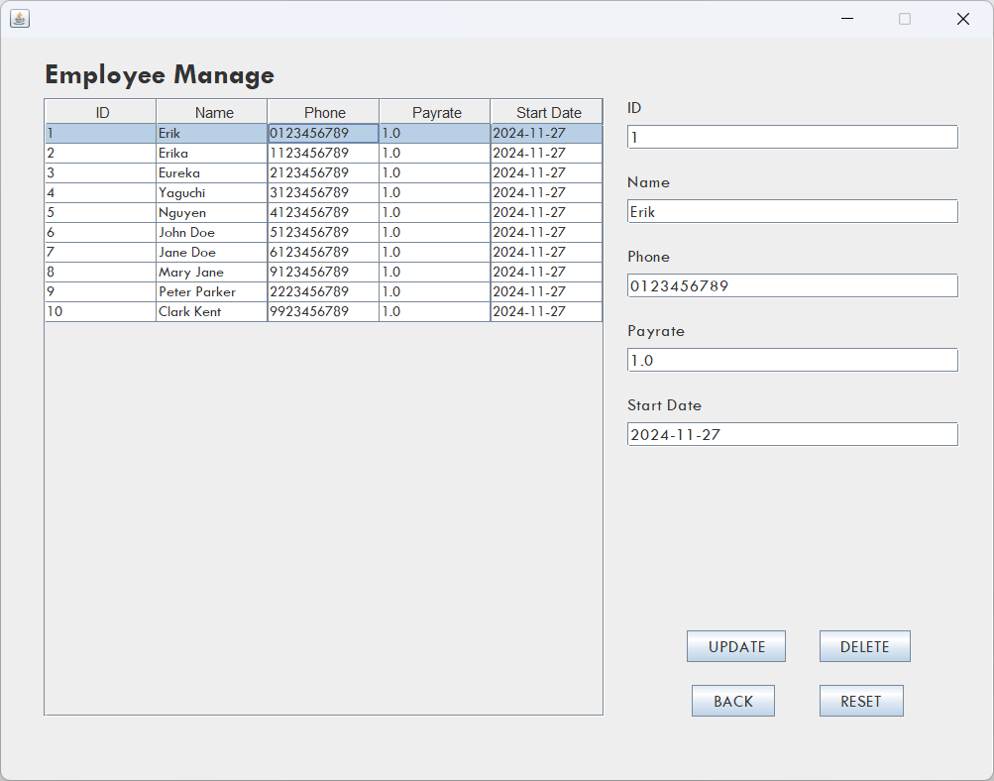
Figure 15: Manage Employee Information
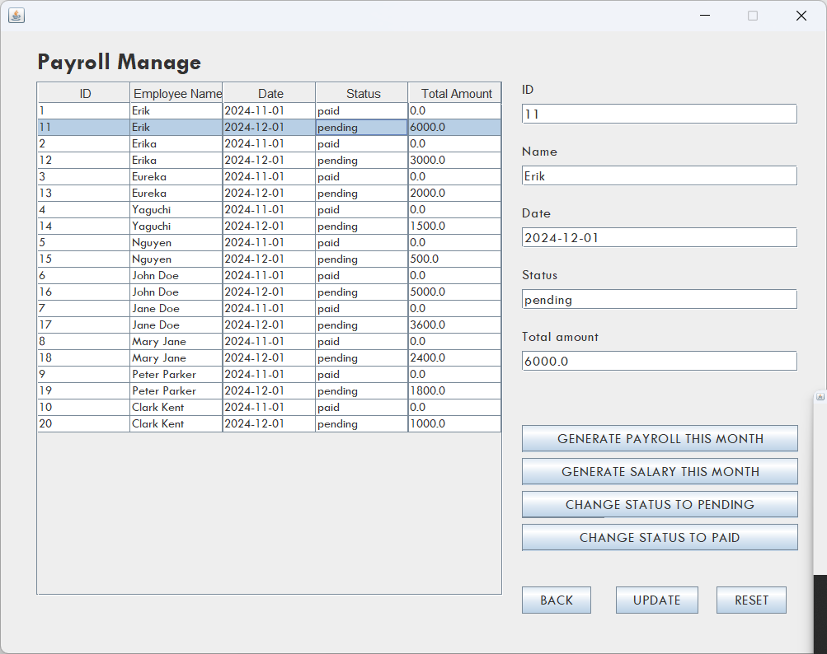
Figure 16: Manage Payroll

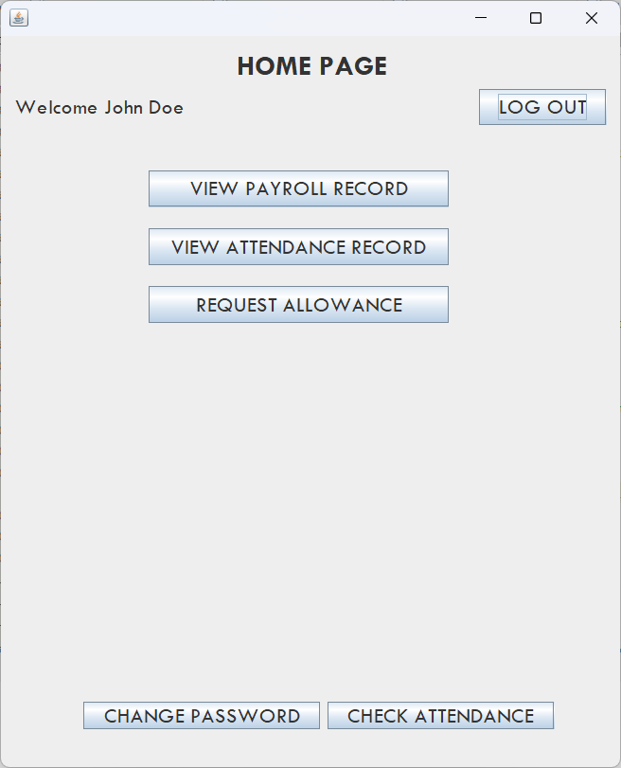
Figure 17: Default Homepage
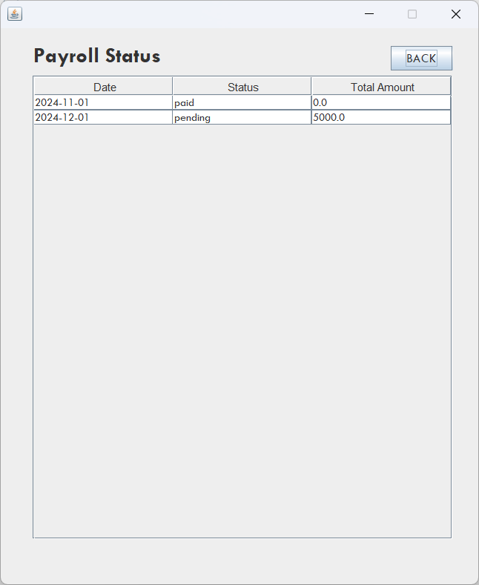
Figure 18: Checking payroll record

Conclusion

Achieved goals

After doing this Payroll Management Solution project, our team has successfully design an application that meet requirement. Few worth noting achievement is that our designed database has achieved B.C. Normal Form. Furthermore, we created a java application that can connect to MySQL database. At the end our project can manage employee information, checking employee attendance, and calculating salary automatically.

The project has taught us how to work as a team, develop a working plan, and conduct proper research to complete a project. Firstly, we researched the appropriate ways to complete the project. Secondly, we designed a database that achieved Boyce Codd normal form and was suitable for our needs. Thirdly, we created a database using MySQL. Lastly, we developed a GUI application using Java and connected it to the database.

Future work
While we have successfully develop an application for this project, however are several ways in which we can improve the application. Firstly, There is a serious security concern with our existing design since it gives HR staff members access to all database data. Therefore, our team will try to implement additional security measures. Secondly, we want to improve the application GUI, and intend to develop an online web application based on this project. Thirdly, our default user doesn’t have many functionalities, so we will increase the capabilities of our default user.

Concluding thoughts
In conclusion, the Payroll Management Solution project enabled the team to effectively apply database management knowledge, particularly in designing and implementing a database system that ensures accurate and secure payroll management. The creation of key tables such as Employee, Salary, and Deductions, along with the use of MySQL and JDBC, established a solid back-end system that supports efficient data retrieval and management. This project will not only enhance the team's SQL skills but also highlight the importance of database design in optimizing performance and security for real-world applications.

List of references
  - PDM Lecture Slide (International University, Course: Principles of Database Management, Instructor: Nguyen Thi Thuy Loan)
  - MySQL Documentation (https://dev.mysql.com/doc/)
  - Normal Form (https://www.geeksforgeeks.org/normal-forms-in-dbms/)
  - Java JDBC API (https://docs.oracle.com/javase/8/docs/technotes/guides/jdbc/)
  - How to determine salary: A global perspective (https://www.oysterhr.com/library/how-to-calculate-salaries-globally)
  - XAMPP Tutorial – javatpoint (https://www.javatpoint.com/xampp)
  - Designing a Swing GUI in NetBeans IDE (https://netbeans.apache.org/tutorial/main/kb/docs/java/quickstart-gui/)
  - What Are the Departments in a Business? (Plus Their Uses) (https://www.indeed.com/career-advice/career-development/business-departments)

